**University of Moratuwa**

**Department of Electronics and Telecommunication**

**EN3160 – Image Processing and Machine Vision**

**Report Activity 01**

**200356A**

Q1.

Q2.

1. White matter enhanced

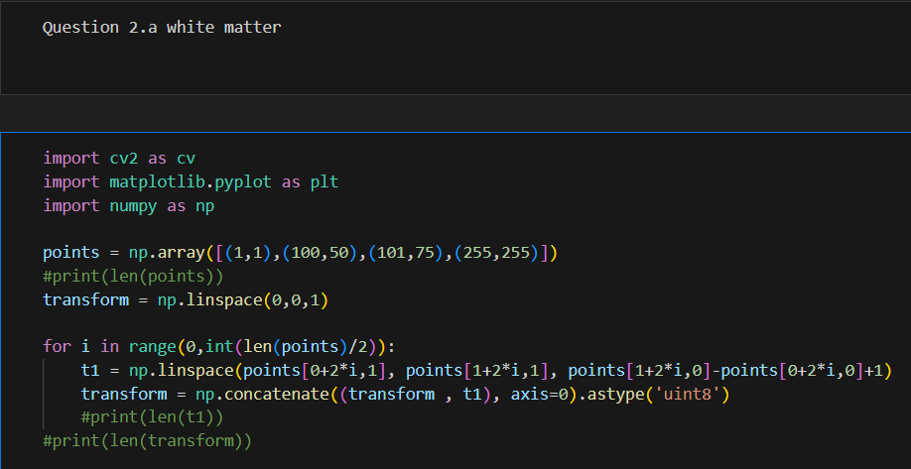

1. Gray matter enhanced

This intensity transform will enhance the gray matter area.

Q3.

Gamma value used = **0.6**

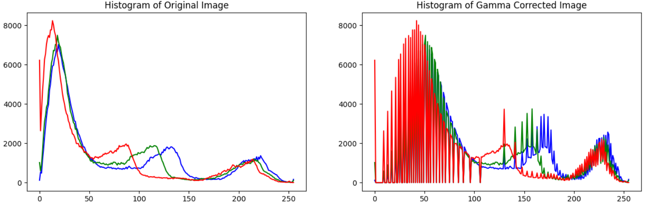

Q4.